**ATTENDANCE SYSTEM USING FACIAL RECOGNITION**

**A CAPSTONE PROJECT REPORT**

*Submitted in partial fulfillment of the*

*requirement for the award of the*

*Degree of*

**BACHELOR OF TECHNOLOGY**

**IN**

**COMPUTER SCIENCE ENGINEERING**

*by*

**ITTA SAI ABHISHEK (18BCN7116)**

*Under the Guidance of*

**DR. PRIYADHARSHINI**



SCHOOL OF COMPUTER SCIENCE ENGINEERING

VIT-AP UNIVERSITY

AMARAVATI- 522237

*JANUARY 2022*

**CERTIFICATE**

This is to certify that the Capstone Project work titled “**ATTENDANCE SYSTEM USING FACIAL RECOGNITION**” that is being submitted by **I SAI ABHISHEK (18BCN7116)** is in partial fulfillment of the requirements for the award of Bachelor of Technology, is a record of bonafide work done under my guidance. The contents of this Project work, in full or in parts, have neither been taken from any other source nor have been submitted to any other Institute or University for award of any degree or diploma and the same is certified.

Dr. PRIYADHARSHINI

Guide

**The thesis is satisfactory / unsatisfactory**

**Internal Examiner External Examiner**

**Approved by**

**PROGRAM CHAIR DEAN**

B. Tech. CSE School of Computer Science Engineering

**ACKNOWLEDGEMENTS**

**ABSTRACT**

In this digital age, where simple everyday life tasks are being automated one of such tasks “Attendance marking” is still being taken manually. We can use face recognition to authenticate the physical presence of a person mark his/her attendance. Face recognition technology is one among the most productive image processing tools and has very important role in the latest technology development fields. Attendance system using facial recognition is a procedure of recognizing students by comparing their face biostatistics and other computational methods. The development of this prototype is aimed to accomplish digitalization of the traditional system of taking attendance by calling each individual and maintaining pen-paper attendance marking process. Present strategies for taking attendance markings are mostly time-consuming and those records can be easily manipulated by manual recording. The traditional process of making attendance and currently used biometric systems are more vulnerable to many proxy methods. This prototype is therefore proposed to be able to tackle all the above stated problems evidently. The system uses the Haar cascade classifiers generative adversarial networks, and LBPH algorithm to detect and compare facial features. After the face recognition, all attendance reports will be generated automatically and will be stored in excel format on the local drive which will be posted to the database later. The proposed system is tested under various conditions like varying illumination, image movements, the variation of distance between the person and camera. After various tests the proposed system proved to be an efficient device for tracking attendance in a classroom with minimal time consumption and no manual work. The system developed is cost-efficient and need minimal maintenance effort once installed.

**TABLE OF CONTENTS**

|  |  |  |  |
| --- | --- | --- | --- |
| **S.No.** | **Chapter** | **Title** | **Page Number** |
| **1.** |  | **Acknowledgement** | **3** |
| **2.** |  | **Abstract** | **4** |
| **3.** |  | **List of Figures and Table** | **6** |
| **4.** | **1**  **1.1**  **1.2**  **1.3**  **1.4** | **Introduction**  **Objectives**  **Background and Literature Survey**  **Previous Work**  **Organization of Report** | **8**  **8**  **8**  **9**  **9** |
| **5.** | **2**  **2.1**  **2.2**  **2.3**  **2.3.1**  **2.3.2**  **2.3.3**  **2.3.4**  **2.4**  **2.4.1**  **2.4.2**  **2.4.3**  **2.5**  **2.5.1**  **2.5.2**  **2.6**  **2.7**  **2.7.1**  **2.7.2** | **Attendance system using**  **facial recognition**  **Proposed System**  **Working Methodology**  **Software Details**  **Tkinter GUI**  **OPENCV**  **HaarCascade Classifier**  **XAMPP Server**  **Face Detection**  **LBPH Algorithm**  **Training the Model**  **Recognition of the image**  **Python GUI**  **Admin Panel**  **Faculty Panel**  **Database**  **Web Portal**  **Faculty Portal**  **Student Portal** | **10**  **10**  **10**  **11**  **11**  **11**  **12**  **12**  **12**  **12**  **14**  **15**  **16**  **16**  **18**  **20**  **21**  **22**  **23** |
| **6.** | **3**  **3.1** | **Cost Analysis**  **List of components and their cost** | **24**  **24** |
| **7.** | **4** | **Results and Discussion** | **25** |
| **8.** | **5** | **Conclusion & Future Works** | **26** |
| **9.** | **6** | **Appendix** | **27** |
| **10.** | **7** | **References** | **47** |

**List of Tables**

**Table No. Title Page No.**

1. Cost Analysis 24

**List of Figures**

|  |  |  |
| --- | --- | --- |
| **Figure No.** | **Title** | **Page No.** |
| 1 | Measuring Facial Features | 8 |
| 2 | Process Flow Diagram | 9 |
| 3 | System Block Diagram | 10 |
| 4 | System Workflow Diagram | 11 |
| 5 | XAMPP Control Panel | 12 |
| 6  7  8  9  10  11  12  13  14  15  16  17  18  19  20  21  22  23 | Pixel value generation using LBPH  Conversion of image to histogram  Euclidean Distance  GUI Login Panel  GUI Admin Panel  New Profile Registration  GUI Faculty Panel  Attendance Tracking  Marked Attendance View  Attendance Edit Option  ER Diagram  Portal Login Page  Faculty Home Page  Faculty Slot View  Student Home Page  Student Slot View  Considered Algorithms  Algorithm Analysis | 13  13  13  16  17  17  18  19  19  20  21  21  22  22  23  23  25  25 |

**CHAPTER 1**

**INTRODUCTION**

A facial recognition system recognizes and matches a specific human face features from a digital picture or video against a database of faces recorded in xml or json formats using wide range of algorithms. It works by locating and measuring facial features such as distance between both the eyes, width of nose etc. from the given image and is mostly used to authenticate a person’s presence.

Figure 1 Measuring Facial Features

In few years, facial recognition technology has advanced rapidly. According to the recent tests conducted by the National Institute of Standards and Technology(NIST), the best face detection algorithm has an error rate of under 0.07 percent as of April 2020, compared to 4.2 percent for the majorly used algorithm in 2014.

Keeping a track of attendance is crucial for both teachers and students in a learning environment. As a result, marking attendance on daily basis manually is a hectic task. Also, the bio-metric systems which are more popularly used to avoid proxy consume a lot of time to mark attendance with huge class strengths. As a result, an automatic attendance system which can mark attendance by detecting the facial features can alleviate all these concerns.

* 1. **Objectives**

The following are the objectives of this project:

* Reducing time wastage during conventional class attendance marking methods.
* Automating the entire attendance system functionalities which requires minimal monitoring and has complete digital environment.
* Evidently narrowing the possibilities for marking proxy attendance.
* Demonstrating the use of latest technology in our daily lives.
  1. **Background and Literature Survey**

The process flow of a face detection and identification system starts with the ability to identify facial characteristics from a live or an image stored in the memory. The system analyses the taken image and determines the number of faces in the image using various system learn patterns to filter out and compare them. This image processing employs several algorithms that consider face expressions and various facial structures and dimensions and compare them to a database of known features

* 1. **Previous Work**

A similar project was done by students at University Tunku in 2017. Their method is also like others and begins with the input of an image either loaded from memory or from camera. Then its system processes the facial features and stores it followed by the recognition of the facial images from files stored in the database. LBP and PCA algorithms are implemented and computed in this approach to make comparisons. LBP is enhanced in this approach to minimize the effects caused by light intensity.

Figure 2 Process Flow Diagram

**1.4 Organization of the Report**

The remaining chapters of the project report are as follows:

* Chapter 2 contains the proposed system, methodology, hardware, and software details.
* Chapter 3 analyzed the cost involved in the implementation of the project.
* Chapter 4 discusses the results obtained after the project implementation.
* Chapter 5 concludes the report.
* Chapter 6 consists of codes.
* Chapter 7 gives references

**CHAPTER 2**

**ATTENDENCE SYSTEM USING FACIAL RECOGNITION**

This Chapter describes the proposed system, working methodology, software, and hardware details.

**2.1 Proposed System**

The following system block diagram (figure 3) shows the system architecture of this project.

Figure 3 System Block Diagram

**2.2 Working Methodology**

The system has two sections, python-based GUI System with image recording and attendance posting options and an online web-portal for attendance view option. Both the GUI System and web portal are linked to a SQL Server where the data will be stored and processed.

Python-based GUI System is a software application that is installed on the system admin and class handing faculty systems. This GUI System allows admin to take new images of students for new registrations or delete the images of past students and re-train the existing model accordingly. Faculty on the other hand can start taking the attendance of the class automatically by triggering the system to switch on the cameras and predict the faces recorded and mark the attendance for the same. The attendance marked is stored in the local memory of faculty system and faculty can view/edit the stored data and post the marking into the database after verification.

Online Web-Portal allows students to login and view all their attendance markings. Also, faculty and admin later can login to their respective account and can view/add/edit/delete any record as per need on the website

Figure 4 System Workflow Diagram

**2.3 Software Details**

This Section describes all the software implementations used for the development of system

**2.3.1 Tkinter GUI**

Tkinter (TK Interface) is a standard cross-platform package for implementing graphical user interface (GUI) using python programming language. It consists of all the required libraries as a single package and can be also used additionally with the other libraries as per requirement.

Importing Tkinter in PYTHON Ver 2.x and above

> import Tkinter as tk

> import tkFileDialog as filedialog

> import ttk

**2.3.2 OPENCV**

OpenCV is a open source software tool used for image processing techniques and computer vision technologies. It is an open-source library for tasks including face identification, objection tracking, landmark detection, and many more image recognition applications. Python, Java, and C++ are among the popular languages supported.

Installing OpenCV for WINDOWS

> pip install opencv-python

> import cv2 as cv

**2.3.3 HaarCascade Classifier**

HaarCascade Classifier is an effective approach used for detecting of certain features in the digital image which was proposed by Paul Vola and Michael Jons through the paper “Rapid Object Detection Methods Using a Boosted Cascade of Simple Features” in the year 2002. This classifier is basically a machine learning based approach in which a group similar and non-similar kind of images are used to train a cascade function through which new images are detected by pattern matching. There are many huge individuals of .xml files with a lot of feature sets and each xml corresponds to a very specific type of use case or pattern to be verified. As we need to identify the facial features and detect the person in this project we will be using “**haarcascade_frontalface_default.xml” for the same.**

**2.3.4 XAMPP Server**

XAMPP is a widely used cross-platform web server application that allows the programmers to write and test their code on a locally created web server. XAMPP is abbreviated as follows, X stands for Cross-Platform, A stands for Apache, M stands for [MY-SQL](https://www.javatpoint.com/mysql-tutorial), and the two P‘s stand for PHP and Perl respectively. It is an open-source software application that incorporates Apache servers and command-line executable files with inbuilt modules such as [MariaDB](https://www.javatpoint.com/mariadb-tutorial), PHP, and Perl. In the current project we will be using PHP for the server-side programming and MYSQL as the database.

**Figure 5 XAMPP Control Panel**

**2.4 Face Detection**

Detailed explanation of functionality of facial recognition system is done in this section

**2.4.1 LBPH Algorithm**

LBPH (Local Binary Pattern Histogram) is a face recognition algorithm used to identify the individual person using his/her facial features. Every image is represented in the form of a matrix composed of rows and columns combining to form many individual cells.

These individual cells are called as pixels. A single pixel is normally defined as least possible information of a bit of image. The value of every pixel in an ranges from 0 to 255. Consider a 3X3 pixel matrix from a given image. We have a total of 9 cells in this matrix. We use LBPH algorithm to define a value to the mid cell with respective to the 8 cells around it.

**Figure 6 Pixel value generation using LBPH**

For each of the neighboring cell of the central cell, we allot a new one-bit binary value. We set 1 for values equal or higher than the given threshold and 0 for values lower. The Threshold(Z) of the central cell using the formula below

Z=∑ s(In - Ic)2^n { Z >= 9 🡪 I = 1 ; Z < 9 🡪 I = 0 }

In the above formula In 🡪 pixel value of the nth cell , Ic 🡪 pixel value of the central cell

Once the one-bit binary values are set we arrange them in the binary form of I0I1I2…In and converting this binary to the decimal value gives the central pixel value. After this process(LBP procedure), we have a newly formed image which represents better the characteristics of the original image with each pixel more related to each other.

Now, using the newly generated image in the previous step, we can use the X and Y grid parameters to further divide the image into multiple grids and form histograms respectively as shown in the image below.

**Figure 7 Conversion of image to histogram**

Once the histograms are created the data is stored in the yml format locally and later to find the similarity between two images, we compare the two histograms formed of respective images and the one with close distance has high similarity. In the current project we will be using Euclidean Distance to compare the histograms.

**Figure 8 Euclidean Distance**

**2.4.2 Training the Model**

We will be using **haarcascade_frontalface_default.xml to detect the face of individuals through the given image. To train the model all the images taken must be scaled down to uniform dimensions and can be done using the code below.**

import cv2

i = cv2.imread('/home/img/python.png', cv2.IMREAD_UNCHANGED)

print('Original Dimensions : ',img.shape)

sp= 60 # percent of original size

width = int(i.shape[1]*sp/100)

height = int(i.shape[0]*sp/100)

dim = (width, height)

resized = cv2.resize(img, dim, interpolation = cv2.INTER_AREA)

print('Resized Dimensions : ',resized.shape)

**Once we scale down all the images to uniform dimensions, we now use Cascade Classifier function of OpenCV to point to the path of the haarcascade_frontal_default.xml in the code below.**

harcascadePath = "haarcascade_frontalface_default.xml"

detector = cv2.CascadeClassifier(harcascadePath)

**Now we load all the images and convert them into grayscale. We perform this operation to remove the RGB (Red, Green, Blue) format in the image and bring down all the computations to 256 bits i.e., Black and White**

gray = cv2.cvtColor(img, cv2.COLOR_BGR2GRAY)

**Once the images are converted to greyscale from RGB format we try to collect all the facial features in the images using an inbuilt method called detectMultiScale as below.**

faces = detector.detectMultiScale(gray, 1.3, 5)

In the above code we are trying to use face_classifier which is an object that is loaded with haarcascade_frontal_default.xml file. This function detects the facial features and record in the object assigned to.

The object from the above step (i.e., faces) in our code returns four values and they are X-Coordinate, Y-Coordinate, Width, Height of the detected face and store the processed images in the memory using below code.

for (x, y, w, h) in faces:

    cv2.rectangle(img, (x, y), (x + w, y + h), (255, 0, 0), 2)

  sampleNum = sampleNum + 1

  cv2.imwrite("TrainingImage\"+Id+'.'+str(sampleNum)+".jpg",gray[y:y+h,x:x +w])

    cv2.imshow('Taking Images', img)

    if cv2.waitKey(100) & 0xFF == ord('q'):

        break

    elif sampleNum > 100:

        break

Once the images are stored, we start training the model using recognizer method and save the trained data in the format of .yml using below code.

recognizer = cv2.face_LBPHFaceRecognizer.create()

    harcascadePath = "haarcascade_frontalface_default.xml"

    detector = cv2.CascadeClassifier(harcascadePath)

    faces, ID = getImagesAndLabels("TrainingImage")

    try:

        recognizer.train(faces, np.array(ID))

    except:

        print(Exception while training model!)

        return

    recognizer.save("TrainingImageLabel\Trainner.yml")

On successful execution of above code, the recorded images are processed, trained and model is saved as Trainner.yml on the local drive.

**2.4.3 Recognition of the Image**

Once the model is trained and saved in the format of .yml successfully we proceed with tracking (detection) of faces in the new images given to the system. We use read() inbuilt method with the recognizer object to read the .yml data and haarcascade_frontalface_default.xml file to extract new face from new image.

recognizer.read("TrainingImageLabel\Trainner.yml")

harcascadePath = "haarcascade_frontalface_default.xml"

faceCascade = cv2.CascadeClassifier(harcascadePath)

Later on, we compare two images using predict() inbuilt method with the recognizer object to get the confidence level(similarity level) of the two files and give a threshold limit such that all the images above this threshold will be accepted to be similar and below will be rejected.

gray = cv2.cvtColor(im, cv2.COLOR_BGR2GRAY)

            faces = faceCascade.detectMultiScale(gray, 1.2, 5)

            for (x, y, w, h) in faces:

                cv2.rectangle(im, (x, y), (x + w, y + h), (225, 0, 0), 2)

                serial, conf = recognizer.predict(gray[y:y + h, x:x + w])

                if (conf > 50):

print(Accepted)

**2.5 Python GUI System**

Functionalities of the GUI System are explained in this section

The entire graphical user interface in this project is developed using TKinter GUI Package Libraries. The first page of the system is the login page where user needs to enter his/her employee ID and password and login to their respective profiles. There are two profiles in the system, and they are Admin and Faculty. Each profile has their own functionalities in them respective to their requirements. Detailed explanation of each profile and their functionalities is given below

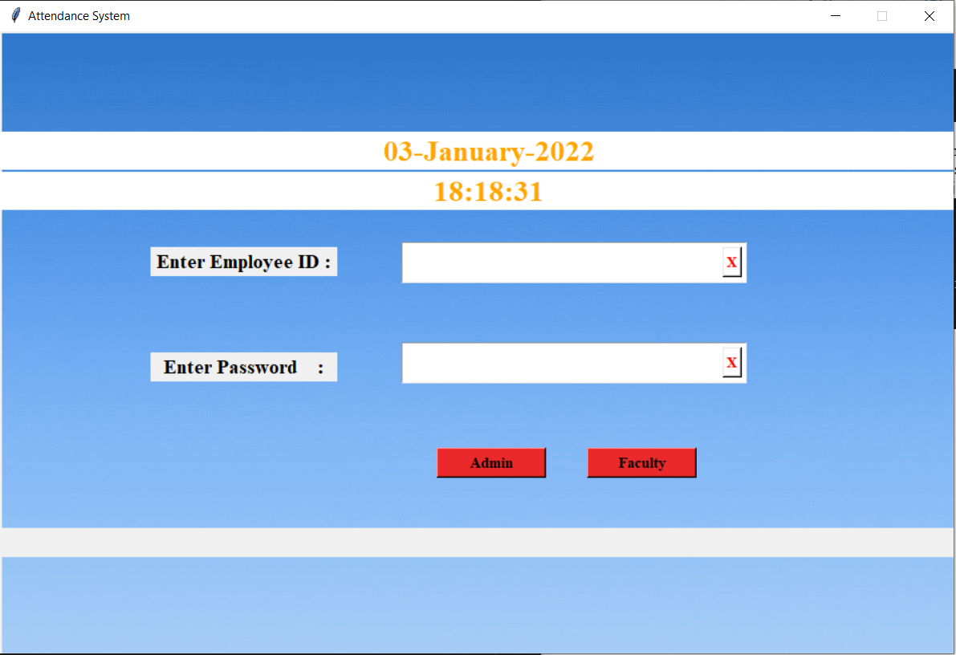

**Figure 9 GUI Login Panel**

**2.5.1 Admin Panel**

The system admin is solely responsible for maintaining class records and updating the trained model with any new changes such as addition/deletion of student images in the system. Admin can also access the images of individual student and entire registration data and trained data (.yml file) to process any necessary corrections in the system.

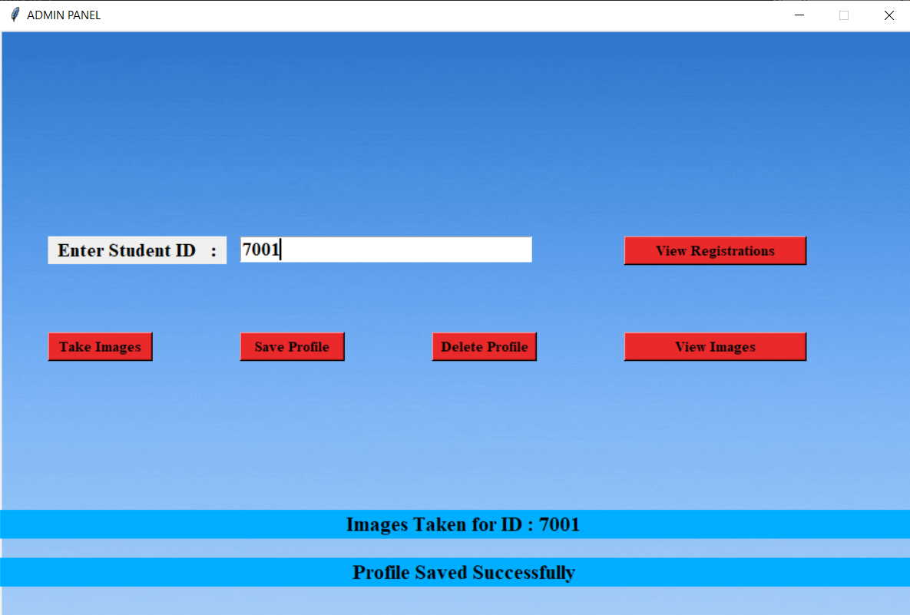

**Figure 10 GUI Admin Panel**

Admin can enter the student ID and check if his/her images are registered and can also delete or add new registrations by using delete profile or take images option and later saving the new profile. Every time admin saves a profile the current existing .yml file gets deleted and new yml file will be generated with the current images available in the system.

To add new student details to the system Admin first selects Take Images option. A camera appears with a blue square around the detected faces. The system is now tracking the images and storing them locally.

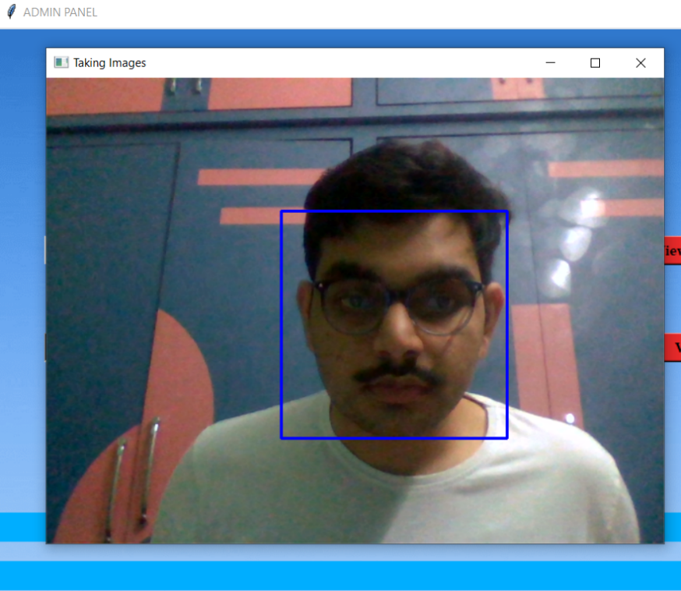

**Figure 11 New Profile Registration**

Admin can manually stop image recording by clicking on ‘q’ key on the keyboard or the system will automatically shut the camera after certain predefined time and saves the images. Once images are recorded successfully, we can proceed with the profile saving option which overrides the current existing .yml file with newly processed data.

**2.5.2 Faculty panel**

Once logged into the system faculty will be directed to a panel as shown in the figure below.

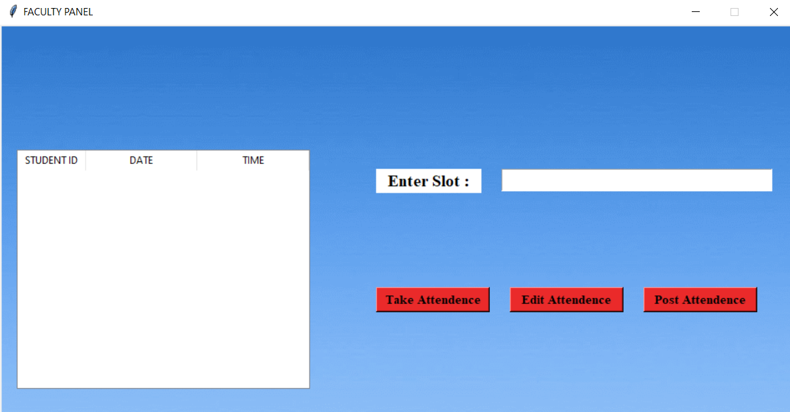

**Figure 12 GUI Faculty Panel**

Faculty need to enter the slot code of the class he/she is wishing to proceed with attendance marking and select the option Take Attendance which switches the cameras on and detects the human face.

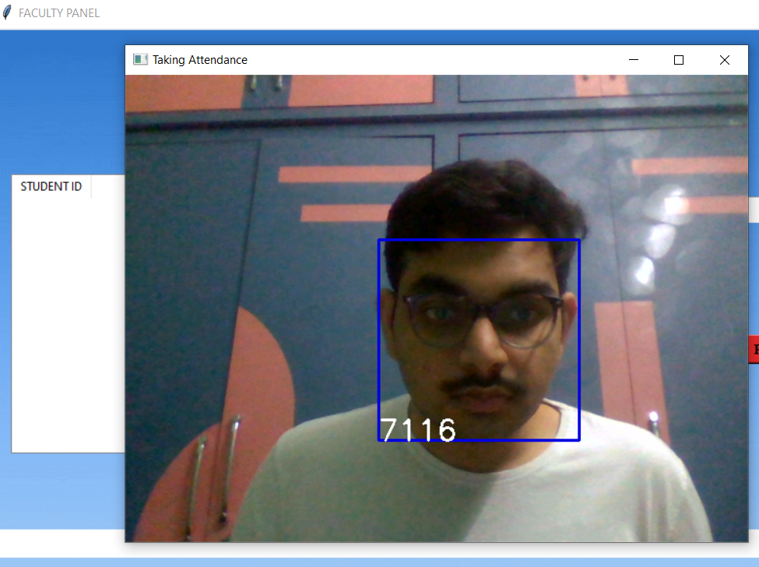

**Figure 13 Attendance Tracking**

The ID of the student will be displayed at the right bottom of the blue square box if system could successfully recognize the person in the image. Faculty can use this option to check if the system is successful in recognition of student. And once the attendance marking is done faculty can close the camera by clicking ‘q’ key on the keyboard

Once faculty finishes the attendance tracking the marked attendance with data and time will be saved in the faculty local drive in the excel format and will also be displayed in the faculty panel as shown in the figure below

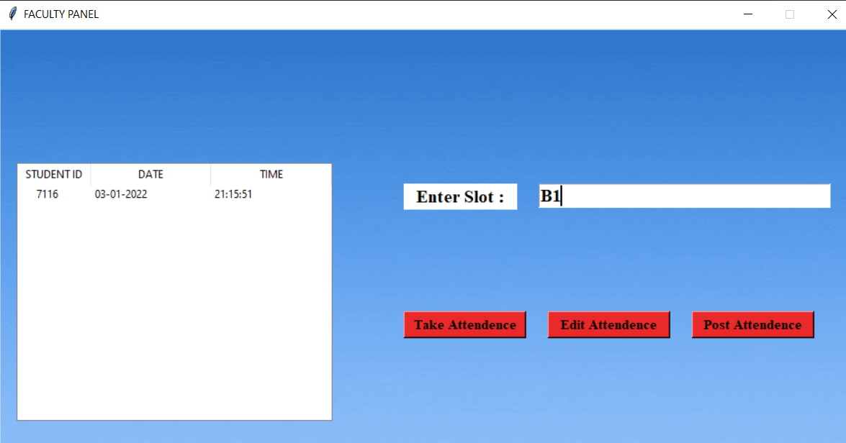

**Figure 14 Marked Attendance View**

If there is any error to be rectified faculty can use Edit Attendance option which will open the excel sheet in which attendance was recorded. Faculty can manually correct any errors that occurred here. Faculty can also manually enter the class attendance in the excel sheet if automatic attendance does not work due to any error in the system.

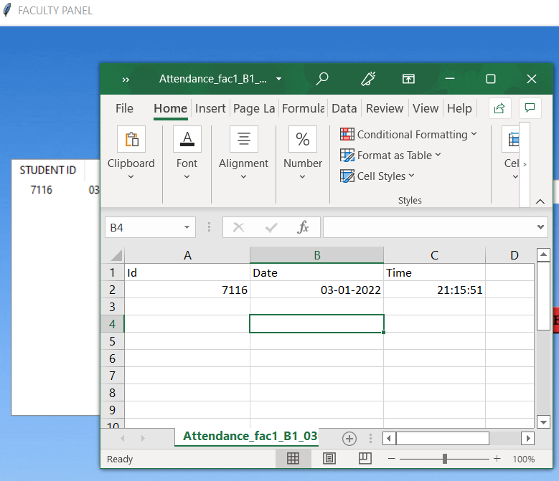

**Figure 15 Attendance Edit Option**

And once faculty verified the marked attendance, they can use Post Attendance option to post the recorded attendance to the SQL Database. Also, the recorded attendance is stored locally on the faculty system in the excel format which allows faculty to post data whenever they are connected to the server without any data loss.

**2.6 Database**

In this project we will be using XAMPP Server for the backend and MYSQL for the database. We are going to implement three tables called ‘adminlogin’, ‘facultylogin’, ‘studentlogin’ which stores the username and password for the respective accounts. To Store attendance records we are going to use three main tables namely ‘atd’,‘faculty_slot’,‘std_registration’ and the entity relationship diagram is given below for these tables

**Figure 16 ER Diagram**

As faculty login with his/her id and choose a slot listed in the faculty_slot table and post the recorded attendance the data will be subsequently posted into the ‘atd’ table with respective facid(faculty id), stdid(student id), slot, date, time. Later students can view his/her respective slot wise attendance details posted to the database on the web portal by logging into their respective account.

**2.7 Web Portal**

The online web portal can be accessed by students to view all their respective class attendance records and faculty/admin have access to their class, attendance records and can also add/delete a student record into the class attendance later using the portal.

**Figure 17 Portal Login Page**

**2.7.1 Faculty Portal**

As faculty login to the portal, they will be redirected to faculty home page where all the courses they are handling will be displayed with an action button called ‘process’ as shown in the figure below.

**Figure 18 Faculty Home Page**

Faculty can later choose a particular class in their course list, and they will be redirected to class detail’s view page where they can choose date and view the students present in the class on that particular date. Faculty can also add new record to the class attendance by selecting the date and entering student id in the respective field and clicking on Add Record button. Also, for each individual record in the attendance view table there is an action button called Delete which will delete that record from the data. Faculty can use this option to delete any attendance record of a student from the class.

**Figure 19 Faculty Slot View**

**2.7.2 Student Portal**

Once student’s login to the portal they will be navigated to student’s home page where they can find all the classes they are registered in as shown in the figure below.

**Figure 20 Student Home Page**

Students can later on choose a particular class to view attendance and they will be navigated to attendance view page where the date and time of the attendance markings will be displayed in order according to slot they have selected.

**Figure 21 Student Slot View**

**CHAPTER 3**

**COST ANALYSIS**

**3.1 List of components and their costs**

As most of the project components are based on open-source software they can be downloaded for free on the internet. The costs of the various components used in this project are given below in Table 3.1.

**Table 3.1 List of components and their costs**

|  |  |
| --- | --- |
| **COMPONENT** | **COST** |
| Python | ₹ 0 |
| TKinter GUI | ₹ 0 |
| OpenCV | ₹ 0 |
| XAMPP Server | ₹ 0 |
| USB Supported Web-Camera | ₹ 700 |
| TOTAL | ₹ 700 |

**CHAPTER 4**

**RESULTS AND DISCUSSIONS**

In the proposed system, face recognition attendance system with user-friendly interface is designed by using Python Tkinter(Graphic User Interface). Buttons designed in the admin interface provide specific functions to perform face recognition automatically according to the face detected, register button allows new registrations of students and save profile button is to train the model with the latest images that have been registered in the system. On the other hand, faculty have a interface which allows them to view current marked attendance and edit if any changes are required at last post option to record entire data in the database. Also, the web portal has required features for the faculty and students to edit/view the marked attendance online anytime. The entire system is self-reliable and need no to minimal monitoring by an external person once the setup is done successfully.

There are three main facial recognition algorithms in the market which we have studied thoroughly before the start of this project. And they are mentioned in the figure below.

**Figure 22 Considered algorithms**

Considering the current project requirements, I have decided to work with the LBPH algorithm for system design. As the integration is simple and backend data to be stored is less compared with the other two algorithms.

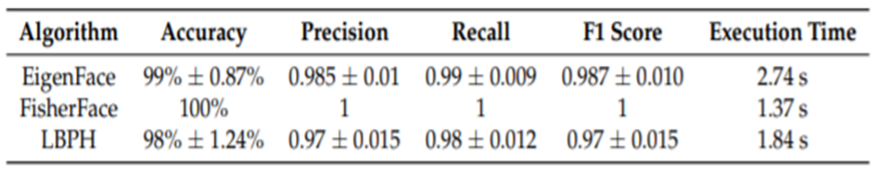

**Figure 23 Algorithm analysis**

Attendance system could bear with any algorithm with accuracy more than 95%. Also, the system need multiple model train calls for every small frequency. This huge data could bring down the system with other algorithms for longer duration with every model train call. On the other hand, LBPH being a bit less accurate can evidently perform well in the above situations. Thus, the current project is developed using LBPH algorithm for the facial recognition.

**CHAPTER 5**

**CONCLUSION AND FUTURE WORK**

The face detection and recognition algorithms were studied thoroughly taking number of the tests from different varying condition images and system performances. Attendance is marked using the recognized face of individual student and the data is stored in an online database making entire process flawless and digital. The attendance marked automatically will also evidently reduce the time taken for the process compared with manual marking or bio-metric methods.

The system can also be made more flexible and scalable by these further improvements in the future work.

* The system can be extended to a greater number of students by creation of different training data set for each individual class and processing the same.
* An SMS alert system can be integrated using GSM Module which sends attendance recording status to the respective students and their parents.
* The system can be made more flexible to allow updating of images in case student has got significant amount of change in his/her facial features over time.
* The system can also be provided with an extension to allow further released face recognition algorithms to integrate in future which could even detect rotational and many more features of face to increase the recognition efficiency.

**CHAPTER 6**

**APPENDIX**

**Python GUI Code**

from io import FileIO

import tkinter as tk

from tkinter import Label, PhotoImage, Tk, ttk

from tkinter import messagebox as mess

import tkinter.simpledialog as tsd

import cv2,ossni

import csv

import numpy as np

from PIL import Image

import pandas as pd

import datetime

import time

import os, glob

import mysql.connector

import MySQLdb

ts = time.time()

date = datetime.datetime.fromtimestamp(ts).strftime('%d-%m-%Y')

day,month,year=date.split("-")

mont={'01':'January', '02':'February','03':'March','04':'April','05':'May','06':'June','07':'July','08':'August''09':'September',

'10':'October', '11':'November','12':'December'}

def check_haarcascadefile():

exists = os.path.isfile("haarcascade_frontalface_default.xml")

if exists:

pass

else:

mess._show(title='File Not Found', message='Cascade File Not Found!!!')

window.destroy()

def assure_path_exists(path):

dir = os.path.dirname(path)

if not os.path.exists(dir):

os.makedirs(dir)

def getImagesAndLabels(path):

imagePaths = [os.path.join(path, f) for f in os.listdir(path)]

faces = []

Ids = []

for imagePath in imagePaths:

pilImage = Image.open(imagePath).convert('L')

imageNp = np.array(pilImage, 'uint8')

print(imagePath)

print(os.path.split(imagePath)[-1])

print(os.path.split(imagePath)[-1].split(".")[0])

ID = int(os.path.split(imagePath)[-1].split(".")[0])

faces.append(imageNp)

Ids.append(ID)

return faces, Ids

def TrainImages():

check_haarcascadefile()

assure_path_exists("TrainingImageLabel/")

recognizer = cv2.face_LBPHFaceRecognizer.create()

harcascadePath = "haarcascade_frontalface_default.xml"

detector = cv2.CascadeClassifier(harcascadePath)

faces, ID = getImagesAndLabels("TrainingImage")

try:

recognizer.train(faces, np.array(ID))

print(ID)

except:

adminpanel.message.configure(text='Please Take Images to proceed with profile saving!')

return

recognizer.save("TrainingImageLabel\Trainner.yml")

res = "Profile Saved Successfully"

adminpanel.message1.configure(text=res)

def TakeImages():

check_haarcascadefile()

columns = ['Student ID']

assure_path_exists("StudentDetails/")

assure_path_exists("TrainingImage/")

serial = 0

exists = os.path.isfile("StudentDetails\StudentDetails.csv")

if (exists==False):

with open("StudentDetails\StudentDetails.csv", 'a+',newline="") as csvFile1:

writer = csv.writer(csvFile1)

writer.writerow(columns)

csvFile1.close()

Id = (adminpanel.studentid.get())

if (Id!=''):

cam = cv2.VideoCapture(0)

harcascadePath = "haarcascade_frontalface_default.xml"

detector = cv2.CascadeClassifier(harcascadePath)

sampleNum = 0

while (True):

ret, img = cam.read()

gray = cv2.cvtColor(img, cv2.COLOR_BGR2GRAY)

faces = detector.detectMultiScale(gray, 1.3, 5)

for (x, y, w, h) in faces:

cv2.rectangle(img, (x, y), (x + w, y + h), (255, 0, 0), 2)

sampleNum = sampleNum + 1

cv2.imwrite("TrainingImage\"+ Id + '.' +str(sampleNum) +".jpg",gray[y:y+h, x:x+w])

cv2.imshow('Taking Images', img)

if cv2.waitKey(100) & 0xFF == ord('q'):

break

elif sampleNum > 100:

break

cam.release()

cv2.destroyAllWindows()

res = "Images Taken for ID : " + Id

row = [Id]

with open('StudentDetails\StudentDetails.csv', 'a+',newline="") as csvFile:

writer = csv.writer(csvFile)

writer.writerow(row)

csvFile.close()

adminpanel.message.configure(text=res)

else:

res = "Enter Correct Student ID!"

adminpanel.message.configure(text=res)

def adminpanel():

if(tkpassword.get()=="" or tkusername.get()=="" ):

tklblerror.config(text="Enter Credentials!")

print("Admin Credentials not entered to login")

import mysql.connector

mydb = MySQLdb.connect(host='localhost',user='root',passwd='',db='capstoneatd')

mycursor = mydb.cursor()

mycursor.execute("SELECT * FROM adminlogin where dbadminid='"+tkusername.get()+"' and dbadmpassword='"+tkpassword.get()+"'")

myresult = mycursor.fetchall()

y=0

for x in myresult:

y=y+1

if(y==1):

window.destroy()

admin=tk.Tk()

admin.geometry("950x620")

admin.resizable(False,False)

bg = PhotoImage(file = "C:/xampp/htdocs/attend - Copy/bg.png")

label1 = Label( admin, image = bg)

label1.place(x = 0, y = 0)

admin.title("ADMIN PANEL")

admin.configure(background='#262523')

tklblstuser = tk.Label(admin, text="Enter Student ID :", width=15, fg="black", height=1, font=('times', 15, ' bold '))

tklblstuser.place(x=50, y=215)

adminpanel.studentid = tk.Entry(admin,width=30 ,fg="black",font=('times', 15, ' bold '))

adminpanel.studentid.place(x=250, y=215)

tknewregistrationbtn = tk.Button(admin, text="Take Images",command=TakeImages,fg="black" ,bg="#ea2a2a" ,width=11 ,activebackground = "white" ,font=('times', 11, ' bold '))

tknewregistrationbtn.place(x=50, y=315)

tksavebtn = tk.Button(admin, text="Save Profile",command=TrainImages,fg="black" ,bg="#ea2a2a" ,width=11 ,activebackground = "white" ,font=('times', 11, ' bold '))

tksavebtn.place(x=250, y=315)

tkdeletebtn = tk.Button(admin, text="Delete Profile",command=deleteprofile,fg="black" ,bg="#ea2a2a" ,width=11 ,activebackground = "white" ,font=('times', 11, ' bold '))

tkdeletebtn.place(x=450, y=315)

tkdviewstdsbtn = tk.Button(admin, text="View Registrations",command=viewregistrations,fg="black" ,bg="#ea2a2a" ,width=20 ,activebackground = "white" ,font=('times', 11, ' bold '))

tkdviewstdsbtn.place(x=650, y=215)

tkviewimagesbtn = tk.Button(admin, text="View Images",command=viewimages,fg="black" ,bg="#ea2a2a" ,width=20 ,activebackground = "white" ,font=('times', 11, ' bold '))

tkviewimagesbtn.place(x=650, y=315)

adminpanel.message = tk.Label(admin, text="" ,bg="#00aeff" ,fg="black" ,width=80,height=1, activebackground = "yellow" ,font=('times', 16, ' bold '))

adminpanel.message.place(x=0, y=500)

adminpanel.message1 = tk.Label(admin, text="" ,bg="#00aeff" ,fg="black" ,width=80,height=1, activebackground = "yellow" ,font=('times', 16, ' bold '))

adminpanel.message1.place(x=0, y=550)

admin.mainloop()

else:

tklblerror.config(text="ID or Password not found for Admin")

print("Admin login failed")

def viewregistrations():

os.startfile("C:\\xampp\\htdocs\\attend - Copy\\StudentDetails\\StudentDetails.csv")

def viewimages():

os.startfile("C:\\xampp\\htdocs\\attend - Copy\\TrainingImage")

def deleteprofile():

if(adminpanel.studentid.get()==""):

adminpanel.message1.config(text="Enter Student ID to Delete Profile")

else:

for filename in glob.glob("C:/xampp/htdocs/attend - Copy/TrainingImage/ "+adminpanel.studentid.get()+"*.jpg"):

os.remove(filename)

def facultypanel():

if(tkpassword.get()=="" or tkusername.get()=="" ):

tklblerror.config(text="Enter Credentials!")

print("Faculty Credentials not entered to login")

return

import mysql.connector

mydb = MySQLdb.connect(host='localhost',user='root',passwd='',db='capstoneatd')

mycursor = mydb.cursor()

mycursor.execute("SELECT * FROM facultylogin where dbfacultyid='"+tkusername.get()+"' and dbfacpassword='"+tkpassword.get()+"'")

myresult = mycursor.fetchall()

y=0

for x in myresult:

y=y+1

if(y==1):

facultypanel.facultyid=tkusername.get()

window.destroy()

admin=tk.Tk()

admin.geometry("950x620")

admin.resizable(False,False)

bg = PhotoImage(file = "C:/xampp/htdocs/attend - Copy/bg.png")

label1 = Label( admin, image = bg)

label1.place(x = 0, y = 0)

admin.title("FACULTY PANEL")

admin.configure(background='#262523')

facultypanel.tv= ttk.Treeview(admin,height =13,columns = ('date','time'))

facultypanel.tv.column('#0',width=82)

#facultypanel.tv.place(x=300,y=100)

#facultypanel.tv.column('name',width=130)

facultypanel.tv.column('date',width=133)

facultypanel.tv.column('time',width=133)

facultypanel.tv.grid(row=2,column=0,padx=(20,20),pady=(150,0),columnspan=4)

facultypanel.tv.heading('#0',text ='STUDENT ID')

#facultypanel.tv.heading('name',text ='NAME')

facultypanel.tv.heading('date',text ='DATE')

facultypanel.tv.heading('time',text ='TIME')

facultypanel.tkslot = tk.Entry(admin,width=32 ,fg="black",font=('times', 15, ' bold ') )

facultypanel.tkslot.place(x=600, y=173)

facultypanel.slotlbl = tk.Label(admin, text="Enter Slot :",bg="white", width=10, fg="black", height=1, font=('times', 15, ' bold '))

facultypanel.slotlbl.place(x=450, y=173)

"""

facultypanel.daylbl = tk.Label(admin, text="Day :",bg="white", width=5, fg="black", height=1, font=('times', 15, ' bold '))

facultypanel.daylbl.place(x=450, y=223)

facultypanel.tkday = tk.Entry(admin,width=5 ,fg="black",font=('times', 15, ' bold ') )

facultypanel.tkday.place(x=520, y=223)

facultypanel.monthlbl = tk.Label(admin, text="Month :",bg="white", width=5, fg="black", height=1, font=('times', 15, ' bold '))

facultypanel.monthlbl.place(x=590, y=223)

facultypanel.tkmonth = tk.Entry(admin,width=5 ,fg="black",font=('times', 15, ' bold ') )

facultypanel.tkmonth.place(x=660, y=223)

facultypanel.tkyear = tk.Entry(admin,width=5,height=1 ,fg="black",font=('times', 15, ' bold ') )

facultypanel.tkyear.place(x=800, y=223)

facultypanel.yearlbl = tk.Label(admin, text="Year :",bg="white", width=5, fg="black", height=1, font=('times', 15, ' bold '))

facultypanel.yearlbl.place(x=730, y=223)

"""

tknewregistrationbtn = tk.Button(admin, text="Take Attendence",command=TrackImages,fg="black" ,bg="#ea2a2a" ,width=14 ,activebackground = "white" ,font=('times', 11, ' bold '))

tknewregistrationbtn.place(x=450, y=315)

tkeditbtn = tk.Button(admin, text="Edit Attendence",command=EditAttendance,fg="black" ,bg="#ea2a2a" ,width=14 ,activebackground = "white" ,font=('times', 11, ' bold '))

tkeditbtn.place(x=610, y=315)

tkpostbtn = tk.Button(admin, text="Post Attendence",command=postattd,fg="black" ,bg="#ea2a2a" ,width=14 ,activebackground = "white" ,font=('times', 11, ' bold '))

tkpostbtn.place(x=770, y=315)

facultypanel.fperror = tk.Label(admin, text="",bg="white", width=80, fg="red", height=1, font=('times', 15, ' bold '))

facultypanel.fperror.place(x=0, y=515)

admin.mainloop()

else:

tklblerror.config(text="ID or Password not found for Faculty")

print("Faculty login failed")

def EditAttendance():

if(facultypanel.tkslot.get()==""):

facultypanel.fperror.config(text="Enter Slot!")

else:

from datetime import date

today = date.today()

d1 = today.strftime("%d%m%Y")

attexists = os.path.isfile("C:\\xampp\\htdocs\\attend - Copy\\Attendance\\Attendance_"+facultypanel.facultyid+"_"+facultypanel.tkslot.get()+"_"+d1+".csv")

if(attexists):

os.startfile("C:\\xampp\\htdocs\\attend - Copy\\Attendance\\Attendance_"+facultypanel.facultyid+"_"+facultypanel.tkslot.get()+"_"+d1+".csv")

facultypanel.fperror.config(text="")

else:

facultypanel.fperror.config(text="Slot Not Found!")

def postattd():

import csv

import MySQLdb

mydb = MySQLdb.connect(host='localhost',user='root',passwd='',db='capstoneatd')

cursor = mydb.cursor()

from datetime import date

today = date.today()

d1 = today.strftime("%d%m%Y")

tbname="Attendance_"+facultypanel.facultyid+"_"+facultypanel.tkslot.get()+"_"+d1

#cursor.execute("Create table "+tbname+" (id varchar(255),date varchar(255),time varchar(255));")

csv_data = csv.reader(open("C:\\xampp\\htdocs\\attend - Copy\\Attendance\\"+tbname+".csv"))

for row in csv_data:

print(row)

print(row[0]+row[1]+row[2])

print("INSERT INTO atd (facid,slot,stdid,date,time) VALUES('"+facultypanel.facultyid+"',"+facultypanel.tkslot.get()+",%s, %s, %s)")

if(row[0]!='Id'):

cursor.execute("INSERT INTO atd (facid,slot,stdid,date,time) VALUES('"+facultypanel.facultyid+"','"+facultypanel.tkslot.get()+"',%s, %s, %s)", row)

mydb.commit()

cursor.close()

print ("Done")

def TrackImages():

if(facultypanel.tkslot.get()==""):

facultypanel.fperror.config(text="Enter Slot!")

else:

print("into else")

check_haarcascadefile()

assure_path_exists("Attendance/")

assure_path_exists("StudentDetails/")

for k in facultypanel.tv.get_children():

facultypanel.tv.delete(k)

msg = ''

i = 0

j = 0

recognizer = cv2.face.LBPHFaceRecognizer_create() # cv2.createLBPHFaceRecognizer()

exists3 = os.path.isfile("TrainingImageLabel\Trainner.yml")

if exists3:

recognizer.read("TrainingImageLabel\Trainner.yml")

else:

mess._show(title='.yml file not found ', message='Please contact admin.')

return

harcascadePath = "haarcascade_frontalface_default.xml"

faceCascade = cv2.CascadeClassifier(harcascadePath)

cam = cv2.VideoCapture(0)

font = cv2.FONT_HERSHEY_SIMPLEX

col_names = ['Id','Date', 'Time']

exists1 = os.path.isfile("StudentDetails\StudentDetails.csv")

if exists1:

df = pd.read_csv("StudentDetails\StudentDetails.csv")

else:

mess._show(title='Student Details Missing in csv format', message='Students details are missing, please check!')

cam.release()

cv2.destroyAllWindows()

window.destroy()

nameList=[]

while True:

ret, im = cam.read()

gray = cv2.cvtColor(im, cv2.COLOR_BGR2GRAY)

faces = faceCascade.detectMultiScale(gray, 1.2, 5)

for (x, y, w, h) in faces:

cv2.rectangle(im, (x, y), (x + w, y + h), (225, 0, 0), 2)

serial, conf = recognizer.predict(gray[y:y + h, x:x + w])

#print(serial)

if (conf < 50):

ts = time.time()

date = datetime.datetime.fromtimestamp(ts).strftime('%d-%m-%Y')

date1 = datetime.datetime.fromtimestamp(ts).strftime('%d%m%Y')

timeStamp = datetime.datetime.fromtimestamp(ts).strftime('%H:%M:%S')

#aa = df.loc[df['SERIAL NO.'] == serial]['NAME'].values

ID = df.loc[df['Student ID'] == serial].values

ID = str(ID)

ID = ID[2:-2]

if str(ID) not in nameList:

nameList.append(str(ID))

attendance = [str(ID), str(date), str(timeStamp)]

ts = time.time()

date = datetime.datetime.fromtimestamp(ts).strftime('%d-%m-%Y')

exists = os.path.isfile("Attendance\Attendance_"+facultypanel.facultyid+"_"+facultypanel.tkslot.get()+"_"+ date1 + ".csv")

if exists:

with open("Attendance\Attendance_"+facultypanel.facultyid+"_"+facultypanel.tkslot.get()+"_"+ date1 + ".csv", 'a+',newline='') as csvFile1:

writer = csv.writer(csvFile1)

writer.writerow(attendance)

csvFile1.close()

else:

with open("Attendance\Attendance_"+facultypanel.facultyid+"_"+facultypanel.tkslot.get()+"_"+ date1 + ".csv", 'a+',newline='') as csvFile1:

writer = csv.writer(csvFile1)

writer.writerow(col_names)

writer.writerow(attendance)

csvFile1.close()

else:

ID = 'Unknown'

cv2.putText(im, ID, (x, y + h), font, 1, (255, 255, 255), 2)

cv2.imshow('Taking Attendance', im)

if (cv2.waitKey(1) == ord('q')):

break

with open("Attendance\Attendance_"+facultypanel.facultyid+"_"+facultypanel.tkslot.get()+"_"+ date1 + ".csv", 'r') as csvFile1:

reader1 = csv.reader(csvFile1)

for lines in reader1:

print(lines)

i = i + 1

if (i > 0):

if (i % 2 == 0):

iidd = str(lines[0]) + ' '

facultypanel.tv.insert('', 0, text=iidd, values=( str(lines[1]), str(lines[2])))

csvFile1.close()

cam.release()

cv2.destroyAllWindows()

def clearusername():

tkusername.delete(first=0,last=10)

def clearpassword():

tkpassword.delete(first=0,last=18)

def tick():

time_string = time.strftime('%H:%M:%S')

clock.config(text=time_string)

clock.after(200,tick)

window = tk.Tk()

window.geometry("950x620")

window.resizable(True,False)

window.title("Attendance System")

window.configure(background='#262523')

window.resizable(False,False)

bg = PhotoImage(file = "C:/xampp/htdocs/attend - Copy/bg.png")

label1 = Label( window, image = bg)

label1.place(x = 0, y = 0)

datef = tk.Label(window, text = day+"-"+mont[month]+"-"+year, fg="orange",bg="white" ,width=57 ,height=1,font=('times', 22, ' bold '))

datef.place(x=0,y=100)

clock = tk.Label(window,fg="orange",bg="white" ,width=57 ,height=1,font=('times', 22, ' bold '))

clock.place(x=0,y=140)

tick()

tklblusername = tk.Label(window, text="Enter Employee ID :", width=15, fg="black", height=1, font=('times', 15, ' bold '))

tklblusername.place(x=150, y=215)

tklblpassword = tk.Label(window, text="Enter Password :", width=15, fg="black", height=1, font=('times', 15, ' bold '))

tklblpassword.place(x=150, y=320)

tkusername = tk.Entry(window, width=20, bg="white", fg="red", font=('times', 25, ' bold '))

tkusername.place(x=400, y=210)

tkpassword = tk.Entry(window, width=20, bg="white", fg="red", font=('times', 25, ' bold '))

tkpassword.place(x=400, y=310)

tkclearusernamebtn = tk.Button(window, text="X", command=clearusername ,fg="red" ,bg="white" ,width=1 ,activebackground = "red" ,font=('times', 11, ' bold '))

tkclearusernamebtn.place(x=720, y=215)

tkclearusernamebtn = tk.Button(window, text="X", command=clearpassword ,fg="red" ,bg="white" ,width=1 ,activebackground = "red" ,font=('times', 11, ' bold '))

tkclearusernamebtn.place(x=720, y=315)

tkfacultyloginbtn = tk.Button(window, text="Faculty", command=facultypanel ,fg="black" ,bg="#ea2a2a" ,width=11 ,activebackground = "white" ,font=('times', 11, ' bold '))

tkfacultyloginbtn.place(x=585, y=415)

tkadminloginbtn = tk.Button(window, text="Admin", command=adminpanel ,fg="black" ,bg="#ea2a2a" ,width=11 ,activebackground = "white" ,font=('times', 11, ' bold '))

tkadminloginbtn.place(x=435, y=415)

tklblerror = tk.Label(window, text="", width=90, fg="red", height=1, font=('times', 15, ' bold '))

tklblerror.place(x=0, y=495)

window.mainloop()

**WEB Portal**

**signin.php**

<?php

$showAlert = false;

$showError = false;

$exists=false;

if($_SERVER["REQUEST_METHOD"] == "POST") {

include 'dbconnect.php';

$username = $_POST["username"];

$password = $_POST["password"];

$category = $_POST["category"];

if($category=='student'){

$sql = "Select * from studentlogin where dbstudentid='$username'and dbstdpassword='$password'";

$result = mysqli_query($conn, $sql);

$num = mysqli_num_rows($result);

}

if($category=='admin'){

$sql = "Select * from adminlogin where dbadminid='$username' and dbadmpassword='$password'";

$result = mysqli_query($conn, $sql);

$num = mysqli_num_rows($result);

}

if($category=='faculty'){

$sql = "Select * from facultylogin where dbfacultyid='$username'and dbfacpassword='$password'";

$result = mysqli_query($conn, $sql);

$num = mysqli_num_rows($result);

}

if($num == 0) {echo"Credentials Not Found!";}

if($num>0)

{

session_start();

$exists="Username not available";

$_SESSION['userid']=$username;

$_SESSION['category']=$category;

$_SESSION['password']=$password;

if($category=='admin')

header("Location: http://localhost/attend%20-%20Copy/portal/admin.php", true, 301);

if($category=='faculty')

header("Location: http://localhost/attend%20-%20Copy/portal/faculty.php", true, 301);

if($category=='student')

header("Location: http://localhost/attend%20-%20Copy/portal/student.php", true, 301);

exit();

}

}

?>

<!doctype html>

<html lang="en">

<head>

<meta charset="utf-8">

<meta name="viewport" content="width=device-width, initial-scale=1,shrink-to-fit=no">

<link rel="stylesheet" href=

"https://stackpath.bootstrapcdn.com/bootstrap/4.5.0/css/bootstrap.min.css"

integrity=

"sha384-9aIt2nRpC12Uk9gS9baDl411NQApFmC26EwAOH8WgZl5MYYxFfc+NcPb1dKGj7Sk"

crossorigin="anonymous">

</head>

<body>

<?php

if($showAlert) {

echo ' <div class="alert alert-success

alert-dismissible fade show" role="alert">

<strong>Success!</strong> Your account is

now created and you can login.

<button type="button" class="close"

data-dismiss="alert" aria-label="Close">

<span aria-hidden="true">×</span>

</button>

</div> ';

}

if($showError) {

echo ' <div class="alert alert-danger

alert-dismissible fade show" role="alert">

<strong>Error!</strong> '. $showError.'

<button type="button" class="close"

data-dismiss="alert aria-label="Close">

<span aria-hidden="true">×</span>

</button>

</div> ';

}

if($exists) {

echo ' <div class="alert alert-danger

alert-dismissible fade show" role="alert">

<strong>Error!</strong> '. $exists.'

<button type="button" class="close"

data-dismiss="alert" aria-label="Close">

<span aria-hidden="true">×</span>

</button>

</div> ';

}

?>

<div class="container my-2 ">

<h1 class="text-center">Online Attendence Portal</h1>

<form action="signin.php" method="post">

<div class="form-group">

<label for="username">User ID :</label>

<input type="text" class="form-control" id="username"

name="username" aria-describedby="emailHelp" style="width:20%;">

</div>

<div class="form-group">

<label for="password">Password :</label>

<input type="password" class="form-control"

id="password" name="password" style="width:20%;">

</div>

<div class="form-group">

<label for="category">Login As :</label><br>

<!--<input type="radio" id="category1" name="category" value="admin">

<label for="category1">Admin&nbsp&nbsp</label>-->

<input type="radio" id="category2" name="category" value="faculty">

<label for="category2">Faculty&nbsp&nbsp</label>

<input type="radio" id="category3" name="category" value="student">

<label for="category3">Student</label><br>

</div>

<button type="submit" class="btn btn-primary">

Login In

</button>

</form>

</div>

<script src="

https://code.jquery.com/jquery-3.5.1.slim.min.js"

integrity="

sha384-DfXdz2htPH0lsSSs5nCTpuj/zy4C+OGpamoFVy38MVBnE+IbbVYUew+OrCXaRkfj"

crossorigin="anonymous">

</script>

<script src="

https://cdn.jsdelivr.net/npm/popper.js@1.16.0/dist/umd/popper.min.js"

integrity=

"sha384-Q6E9RHvbIyZFJoft+2mJbHaEWldlvI9IOYy5n3zV9zzTtmI3UksdQRVvoxMfooAo"

crossorigin="anonymous">

</script>

<script src="

https://stackpath.bootstrapcdn.com/bootstrap/4.5.0/js/bootstrap.min.js"

integrity=

"sha384-OgVRvuATP1z7JjHLkuOU7Xw704+h835Lr+6QL9UvYjZE3Ipu6Tp75j7Bh/kR0JKI"

crossorigin="anonymous">

</script>

</body>

</html>

**dbconnect.php**

<?php

$servername = "localhost";

$username = "root";

$password = "";

$database = "capstoneatd";

$conn = mysqli_connect($servername,$username, $password, $database);

if($conn) {

#echo "success";

}

else {die("Error". mysqli_connect_error());}

?>

**faculty.php**

<?php

session_start();

if(!isset($_SESSION["userid"]))

header("Location: http://localhost/attend%20-%20Copy/portal/signin.php", true, 301);

#echo"home page ".$_SESSION["userid"]." ".$_SESSION['category'];

?>

<!DOCTYPE html>

<html>

<head>

<style>

table {

border-collapse: collapse;

width: 60%;

padding: 10%;

}

th, td {

text-align: left;

padding: 8px;

}

tr:nth-child(even){background-color: #f2f2f2}

th {

background-color: #157DEC;

color: white;

}

#head{

background-color: red;

}

</style>

<meta charset="utf-8">

<meta name="viewport" content=

"width=device-width, initial-scale=1,

shrink-to-fit=no">

<link rel="stylesheet" href=

"https://stackpath.bootstrapcdn.com/bootstrap/4.5.0/css/bootstrap.min.css"

integrity=

"sha384-9aIt2nRpC12Uk9gS9baDl411NQApFmC26EwAOH8WgZl5MYYxFfc+NcPb1dKGj7Sk"

crossorigin="anonymous">

<title>Faculty</title>

</head>

<body>

<div id="head">

<a style{align:left;} href="logout.php">Logout</a>

</div>

<div id="cont">

<center>

<h2>Your Courses</h2>

<table border="4">

<tr>

<th><b>Sr.No.</b></td>

<th><b>Slot</b></td>

<th><b>Course Name</b></td>

<th><b>Action</b></td>

</tr>

<?php

include "dbconnect.php"; // Using database connection file here

$id=$_SESSION["userid"];

$records = mysqli_query($conn,"select * from faculty_slot where facid='$id'"); // fetch data from database

$i=1;

while($data = mysqli_fetch_array($records))

{

?>

<tr>

<td><?php echo $i++; ?></td>

<td><?php echo $data['slot']; ?></td>

<td><?php echo $data['coursename']; ?></td>

<td><a href="fatdv.php?id=<?php echo $data['facid']."-".$data['slot']; ?>">Process</a></td>

</tr>

<?php

}

?>

</table>

</div>

</body>

</html>

**fatdv.php**

<?php

session_start();

if(!isset($_SESSION["userid"]))

header("Location: http://localhost/attend%20-%20Copy/portal/signin.php", true, 301);

if(isset($_GET['id'])){

$cred=explode("-",$_GET['id']);

$_SESSION['facid']=$cred[0];

$_SESSION['slot']=$cred[1];}

$date=0;

if($_SERVER["REQUEST_METHOD"] == "POST"){

if(isset($_POST['viewbtn'])){

$date=$_POST['date'];

$cred=explode("-",$date);

$date=$cred[2]."-".$cred[1]."-".$cred[0];}

if(isset($_POST['addbtn']) && isset($_POST['date']) ){

include "dbconnect.php";

$facid=$_SESSION['facid'];$slot=$_SESSION['slot'];

$date=$_POST['date'];$stdid=$_POST['stdid'];

$cred=explode("-",$date);

$date=$cred[2]."-".$cred[1]."-".$cred[0];

$sql = "INSERT INTO atd (facid, slot, stdid,date,time)

VALUES ('$facid', '$slot', '$stdid','$date','-')";

if ($conn->query($sql) === TRUE) {

#echo "New record created successfully";

} else {

echo "Error: " . $sql . "<br>" . $conn->error;

}

}

}

?>

<!DOCTYPE html>

<html>

<head>

<title>Faculty</title>

<style>

table {

border-collapse: collapse;

width: 60%;

padding: 10%;

}

th, td {

text-align: left;

padding: 8px;

}

tr:nth-child(even){background-color: #f2f2f2}

th {

background-color: #157DEC;

color: white;

}

#head{

background-color: red;

}

#formid{

padding:20px;

}

</style>

<meta charset="utf-8">

<meta name="viewport" content=

"width=device-width, initial-scale=1,

shrink-to-fit=no">

<link rel="stylesheet" href=

"https://stackpath.bootstrapcdn.com/bootstrap/4.5.0/css/bootstrap.min.css"

integrity=

"sha384-9aIt2nRpC12Uk9gS9baDl411NQApFmC26EwAOH8WgZl5MYYxFfc+NcPb1dKGj7Sk"

crossorigin="anonymous">

</head>

<div id="head">

<a style{align:left;} href="logout.php">Logout</a>

</div>

<body>

<div id='formid'>

<form action="fatdv.php" method="post">

<h2><?php echo('Slot - '.$_SESSION['slot']." ");?>Attendence Details</h2>

<label for="username">Choose Date :</label>

<input type="date" class="form-control" id="date"name="date" style="width:20%;"><br>

<input type="submit" name="viewbtn" value="View Attendence" class="btn btn-primary"><br><br>

<label for="username">Student ID &nbsp&nbsp :</label>

<input type="text" class="form-control" id="stdid"name="stdid" style="width:20%;"><br>

<input type="submit" name="addbtn" value="Add Record" class="btn btn-primary">

</form>

</div>

<center>

<br>

<table border="2">

<tr>

<th>Sr.No.</td>

<th>Student ID</td>

<th>Date</td>

<th>Time</td>

<th>Action</td>

</tr>

<?php

include "dbconnect.php";

$facid=$_SESSION['facid'];$slot=$_SESSION['slot'];

$records = mysqli_query($conn,"select * from atd where facid='$facid' and slot='$slot' and date='$date'");

$i=1;

while($data = mysqli_fetch_array($records))

{

?>

<tr>

<td><?php echo $i++; ?></td>

<td><?php echo $data['stdid']; ?></td>

<td><?php echo $data['date']; ?></td>

<td><?php echo $data['time']; ?></td>

<td><a href="fatdv.php?id=<?php echo $data['facid']."-".$data['slot']; ?>">Delete</a></td>

</tr>

<?php

}

?>

</table><br><br>

<a href="faculty.php">Back</a>

</body>

</html>

**student.php**

<?php

session_start();

if(!isset($_SESSION["userid"]))

header("Location: http://localhost/attend%20-%20Copy/portal/signin.php", true, 301);

echo"Logged in ".$_SESSION["userid"];

?>

<!DOCTYPE html>

<html>

<style>

table {

border-collapse: collapse;

width: 60%;

padding: 10%;

}

th, td {

text-align: left;

padding: 8px;

}

tr:nth-child(even){background-color: #f2f2f2}

th {

background-color: #157DEC;

color: white;

}

#head{

background-color: red;

}

#formid{

padding:20px;

}

</style>

<meta charset="utf-8">

<meta name="viewport" content=

"width=device-width, initial-scale=1,

shrink-to-fit=no">

<link rel="stylesheet" href=

"https://stackpath.bootstrapcdn.com/bootstrap/4.5.0/css/bootstrap.min.css"

integrity=

"sha384-9aIt2nRpC12Uk9gS9baDl411NQApFmC26EwAOH8WgZl5MYYxFfc+NcPb1dKGj7Sk"

crossorigin="anonymous">

<head>

<title>Student</title>

</head>

<body>

<div id="head">

<a style{align:left;} href="logout.php">Logout</a>

</div>

<center>

<h2>Your Course Details</h2>

<table border="2">

<tr>

<td>Sr.No.</td>

<td>course title</td>

<td>Slot</td>

<td>Action</td>

</tr>

<?php

$id=$_SESSION["userid"];

include "dbconnect.php"; // Using database connection file here

$records = mysqli_query($conn,"select * from std_registration where stdid='$id'"); // fetch data from database

$i=1;

while($data = mysqli_fetch_array($records))

{

$clsid=$data['classid'];

$records1 = mysqli_query($conn,"select * from faculty_slot where classid='$clsid'");

while($data1 = mysqli_fetch_array($records1)){

?>

<tr>

<td><?php echo $i++; ?></td>

<td><?php echo $data1['coursename'];?></td>

<td><?php echo $data1['slot']; ?></td>

<td><a href="satdv.php?id=<?php echo $data1['facid']."-".$data1['slot']; ?>">View Attendance</a></td>

</tr>

<?php

}

}

?>

</table>

<script src="https://cdnjs.cloudflare.com/ajax/libs/Chart.js/2.5.0/Chart.min.js"></script>

<canvas id="myChart" style="width:100%;max-width:600px"></canvas>

<script>

/*var xValues = ["Italy", "France", "Spain", "USA", "Argentina"];

var yValues = [55, 49, 44, 24, 15];

var barColors = ["red", "green","blue","orange","brown"];

new Chart("myChart", {

type: "bar",

data: {

labels: xValues,

datasets: [{

// backgroundColor: barColors,

data: yValues

}]

},

options: {

legend: {display: false},

title: {

display: true,

text: "Attendence Percentage"

}

}

});*/

</script>

</body>

</html>

**satdv.php**

<?php

session_start();

if(isset($_GET['id'])){

$cred=explode("-",$_GET['id']);

$_SESSION['facid']=$cred[0];

$_SESSION['slot']=$cred[1];}

?>

<?php

if(!isset($_SESSION["userid"]))

header("Location: http://localhost/attend%20-%20Copy/portal/signin.php", true, 301);

echo"Logged in ".$_SESSION["userid"];

?>

<!DOCTYPE html>

<html>

<style>

table {

border-collapse: collapse;

width: 60%;

padding: 10%;

}

th, td {

text-align: left;

padding: 8px;

}

tr:nth-child(even){background-color: #f2f2f2}

th{

background-color: #157DEC;

color: white;

}

#head{

background-color: red;

}

#formid{

padding:20px;

}

</style>

<meta charset="utf-8">

<meta name="viewport" content=

"width=device-width, initial-scale=1,

shrink-to-fit=no">

<link rel="stylesheet" href=

"https://stackpath.bootstrapcdn.com/bootstrap/4.5.0/css/bootstrap.min.css"

integrity=

"sha384-9aIt2nRpC12Uk9gS9baDl411NQApFmC26EwAOH8WgZl5MYYxFfc+NcPb1dKGj7Sk"

crossorigin="anonymous">

<head>

<div id="head">

<a style{align:left;} href="logout.php">Logout</a>

</div>

<title>Attendance Details</title>

</head>

<body>

<center>

<h2><?php echo('Slot - '.$_SESSION['slot']." ");?>Attendence Details</h2>

<br>

<table border="2">

<tr>

<td>Sr.No.</td>

<td>Date</td>

<td>Time</td>

</tr>

<?php

include "dbconnect.php";

$facid=$_SESSION['facid'];$slot=$_SESSION['slot'];

$stdid=$_SESSION["userid"];

$records = mysqli_query($conn,"select * from atd where facid='$facid' and slot='$slot' and stdid='$stdid'");

$i=1;

while($data = mysqli_fetch_array($records))

{

?>

<tr>

<td><?php echo $i++; ?></td>

<td><?php echo $data['date']; ?></td>

<td><?php echo $data['time']; ?></td>

</tr>

<?php

}

?>

</table><br><br>

<a href="student.php">Back</a>

</body>

</html>

**logout.php**

<?php

session_start();

session_destroy();

header("Location: http://localhost/attend%20-%20Copy/portal/signin.php", true, 301);

?>

**REFERENCES**

[1] Bumikha G. Bhat, Zakhana H.Sha “Face Feature Extraction Techniques”, National Conference on Recent Trends in Engineering & Technology, 13-15 May 2011.

[2] P. Yang and T. K. Huang, “Human face detection in complexity,” Pattern Recognition Method, vol. 17, no.2, pp. 53-68, 1994.

[3] C. Ketropoulus and I. Patis, “Rule-based face detection in frontal views,” Proc. Int’l Conf. Acoustics, Speech and Signal Processing, vol. 4, pp. 2537-2540, 1997.

[4] E. Saber and A.M. Takalp, “Frontal-view face detection and facial feature extraction using color, shape and symmetry-based cost functions,” Pattern Recognition Letters, vol. 17, no. 8, pp. 669-680, 1998.

[5] M. Turk, A. Pentland, Eigenfaces for Recognition, Journal of Cognitive Neurosicence, Vol. 3, No. 1, Win. 1991, pp. 71-86

[6] Discriminant analysis for recognition of human face images Kamran Etemad and Rama Chellappa

**BIODATA**

Photo

Name : I Sai Abhishek

Mobile Number : 9493911988

E-mail : abhishek.18bcn7116@vitap.ac.in

Permanaent Address : Nizampet, Hyderabad

**NOTE:** Its **MANDATORY** for a student to attach all the PPT’s, Sample Materials, Specification Sheets, Programming Codes and a 5-10 minutes demo Video of the Project Digitally In CD . Stick the Compact Disk (CD) in the final page of the Thesis after binding it.